Project Design Phase-II
Data Flow Diagram & User Stories

Date | 28 September 2026
Team ID | 6ab64cc2da631abbf0cd4d07
Project Name | AI WeatherWise API
Maximum Marks | 4 Marks

Data Flow Diagrams:
A Data Flow Diagram (DFD) is a traditional visual representation of the information flows within a system. A neat and clear DFD can depict the right amount of the system requirement graphically. It shows how data enters and leaves the system, what changes the information, and where data is stored.
AI WeatherWise API — DFD Level 0
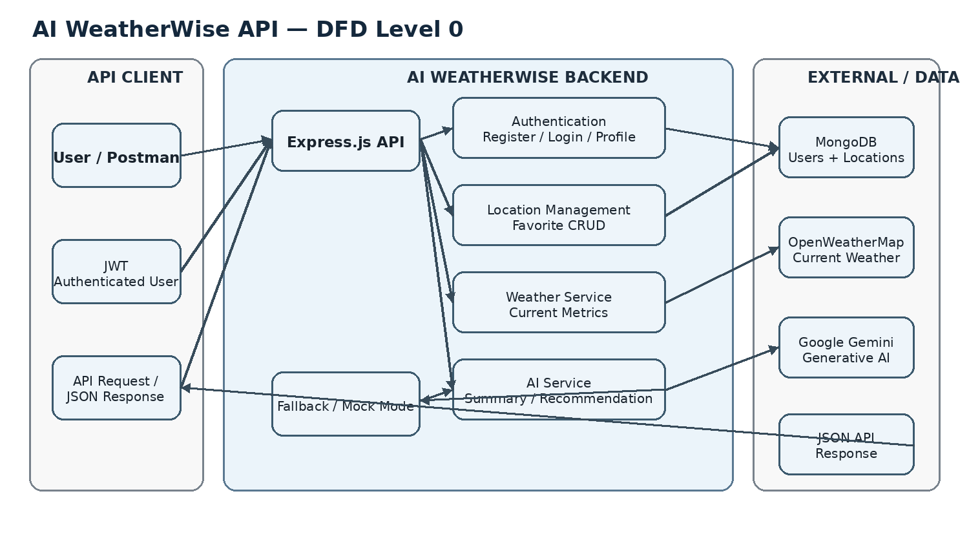

User Stories
Use the below template to list all the user stories for the product.
User Type | Functional Requirement (Epic) | User Story Number | User Story / Task | Acceptance criteria | Priority | Release
API User | Registration | USN-1 | As a user, I can register with my name, email and password. | A new account is created and a JWT token is returned. | High | Sprint-1
API User | Login | USN-2 | As a user, I can log in with my email and password. | Valid credentials return a JWT token. | High | Sprint-1
Authenticated User | Profile | USN-3 | As a user, I can view my profile using my JWT token. | Authenticated profile details are returned. | Medium | Sprint-1
API User | Weather | USN-4 | As a user, I can request current weather for a city. | Temperature, humidity, wind speed and condition are returned. | High | Sprint-1
Authenticated User | Favorite Locations | USN-5 | As a user, I can add a city to my favorite locations. | The city and country are saved for the logged-in user. | High | Sprint-1
Authenticated User | Favorite Locations | USN-6 | As a user, I can view my saved favorite locations. | Saved locations are returned. | Medium | Sprint-1
Authenticated User | Favorite Locations | USN-7 | As a user, I can update a saved favorite location. | The selected location is updated by its ID. | Medium | Sprint-2
Authenticated User | Favorite Locations | USN-8 | As a user, I can delete a saved favorite location. | The selected location is removed. | Medium | Sprint-2
Authenticated User | AI Weather Insights | USN-9 | As a user, I can generate an AI weather summary. | A natural-language weather summary is returned. | High | Sprint-2
Authenticated User | AI Weather Insights | USN-10 | As a user, I can request weather recommendations. | Personalized clothing/activity suggestions are returned. | High | Sprint-2
API User | Fallback Mode | USN-11 | As a user, I can test weather and AI endpoints when external API keys are unavailable. | Stable rule-based mock responses are returned. | Medium | Sprint-2
API User | API Testing | USN-12 | As a user/developer, I can test the API through Postman. | Auth, location, weather and AI requests can be executed and verified. | Medium | Sprint-2

